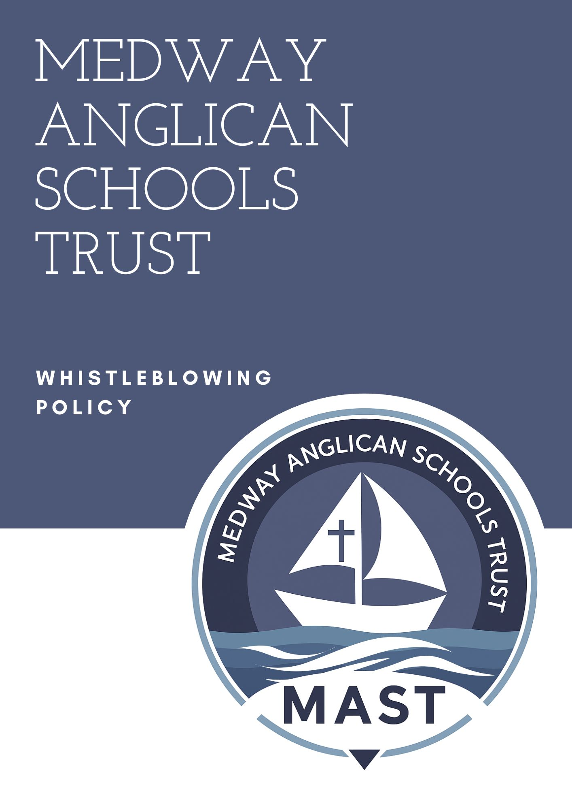

WHAT IS 'WHISTLEBLOWING'?

Whistleblowing inside the work place is the term used to describe reporting by employees or ex-employees, of wrongdoing on the part of management, the Trust Board, Governing Body or by fellow employees. Wrongdoing may include for example, fraud, corruption, malpractice, breach of health and safety law, any other illegal or unethical act or breaches of the Trust Code of Conduct. Employees may, for this purpose include, for example, contractors and agency workers.

2. LEGAL FRAMEWORK

This policy has due regard to all relevant legislation and guidance including, but not limited to, the following:

Public Interest Disclosure Act 1998

Employment Rights Act 1996

ESFA ‘Academy trust handbook’

DfE *Keeping Children Safe in Education (KCSIE) 2025*, including Part One (to be read by all staff) and Annex A where appropriate]

GOV.UK (2012) ‘Whistleblowing for employees’

This policy operates in conjunction with the following school policies:

Disciplinary Policy and Procedure

Complaints Procedures Policy

Data Protection Policy

PROTECTING THE WHISTLEBLOWER

Under the Public Interest Disclosure Act 1998 (PIDA) a Whistleblower is protected from detriment and unfair dismissal. The Trust will support and not discriminate against concerned employees who apply the Whistleblowing procedure, provided any claim is made in good faith.

PIDA protects employees who “blow the whistle” where the employee reasonably believes that the disclosure falls within the remit of the prescribed person or body, and that the information and any allegations are substantially true.
Disclosures made under this procedure will be monitored for statistical purposes as required under the PIDA. The details of any disclosure will remain confidential.

The headteacher is the first point of contact for whistleblowing queries. If the allegation is related to the headteacher, the concern will be raised with the chair of governors.
Any member of the school community or the general public is able to “blow the whistle”; however, the PIDA only protects employees.

This policy applies to all those working in or for the Trust, including employees, agency staff, contractors, and volunteers. While legal protections under PIDA apply only to employees, the Trust will ensure that volunteers, supply staff and others are supported, protected from retaliation, and able to raise concerns safely.

WHEN SHOULD WHISTLEBLOWING PROCEDURES BE USED?

If an employee has concerns about wrongdoing at the Trust and feels that those concerns are sufficiently serious to require reporting, this procedure outlines what should be done.

Each individual member of staff should feel able to speak freely on such matters. However, the Trust and colleagues have the right to protect themselves against unfounded false or malicious accusations.

Whistleblowing should only be used when the party implementing the procedure (Representor) has reasonable grounds for believing that a serious offence has been or may be committed. It must never be used without good grounds, falsely or maliciously.

Whistleblowing is not appropriate for dealing with issues between an employee and the Trust which relate to the employee's own employment or rights or employment conditions generally. Alternative dispute resolution procedures for that purpose are outlined in the employment terms and conditions.

Whistleblowing is not appropriate for dealing with pupil complaints, which will be dealt with under separately published procedures.

Whistleblowing is not appropriate to specific cases of child safety or safeguarding which will be dealt with under the procedures specified in that connection. If any staff member has concerns that a pupil is being dealt with unfairly in school, they should raise their concern, in the first instance with the Headteacher or Child Protection Officer/DSL.

If a member of staff feels like they are unable to raise a safeguarding-related concern with the school, or feels that their genuine concerns are not being addressed, they are able to contact the Medway Local Area Designated Officer (LADO) 01634 331065 or NSPCC Whistleblowing Helpline on 0800 028 0285.

4.8 The school, or the appropriate external agency, will acknowledge receipt of a disclosure but, unless additional information is required, will not contact or engage in dialogue with the whistleblower, as this may undermine the legitimacy of the investigation outcome.

4.9 Staff are encouraged to raise not only serious safeguarding or misconduct concerns but also *low-level concerns* or “whispers” about staff behaviour that do not meet the threshold for formal action. These will be recorded and monitored in line with KCSIE 2025 to help identify potential patterns.

THE PROCEDURE

Any issue raised will be kept confidential while the procedure is being used.

The Representor (the person raising the concern) should raise their concern with their line manager. This may be done orally or in writing.

However, if the concern relates to the Representor's line manager or any person to whom he or she reports, other than the Headteacher, the Representor should raise the issue with the Headteacher.

If the concern relates to the Headteacher, the Representor should raise the matter with the CEO of the Trust.

5.5 If the concern relates to the CEO, the Representor should raise the matter with the Chair of Trustees via the Governance Professional.

The person with whom the matter is raised is referred to as the "Assessor".

The Assessor will:

Interview the Representor as soon as possible within seven working days, in confidence. Early interview will be essential if the concern relates to an immediate danger to loss of life or serious injury or risk to pupils;

Obtain as much information as possible from the Representor about the grounds for the belief of wrongdoing;

Consult with the Representor about further steps which could be taken;

Advise the Representor of the appropriate route if the matter does not fall under this Procedure;

Report all matters raised under this procedure to the Chair of the Governing Body and the CEO/Chair of Trustees (Appendix 1)

All staff must be reminded that if they feel unable to raise concerns internally, or if concerns are not being dealt with properly, they may contact external bodies directly, such as Ofsted, the NSPCC Whistleblowing Helpline, the DfE, ESFA, or other agencies listed in Appendix 2.

At the interview with the Assessor, the Representor may be accompanied by a recognised trade union representative or a work colleague. The Assessor may be accompanied by a member of the Trust staff to take notes.

The Assessor may at any time disclose the matter to a professionally qualified lawyer for the purpose of taking legal advice. The Assessor may also discuss the issue, in confidence, to other suitable professionals, such as independent HR consultants or school governance providers in order to assess the nature of the case and to inform the outcome of the investigation.

Promptly within ten working days of the interview, the Assessor will recommend one or more of the following:

The matter be further investigated internally by the Trust;

The matter be further investigated by external consultants appointed by the Trust;

The matter be reported to an external agency;

Disciplinary proceedings be implemented against an employee;

The route for the Representor to pursue the matter if it does not fall within this procedure; or

That no further action is taken by the Trust.

The grounds on which no further action is taken include:

The Assessor is satisfied that, on the balance of probabilities, there is no evidence that wrongdoing within the meaning of this procedure has occurred, is occurring or is likely to occur;

The Assessor is satisfied that the Representor is not acting in good faith;

The matter is already (or has been) the subject of proceedings under one of the Trust’s other procedures or policies;

The matter concerned is already (or has been) the subject of legal proceedings, or has already been referred to an external agency.

The recommendation of the Assessor will be made to the Headteacher. However, should it be alleged that the Headteacher is involved in the alleged wrongdoing; the recommendation will be made to the Trust Board and the Chair of the Local Governing Body.

The Headteacher or Chair of the Governing Body, as appropriate, will ensure that the recommendation is implemented unless there is good reason for not doing so in whole or in part. Such a reason will be reported to the next meeting of the Local Governing Body. The minutes of the Local Governing Body will be sent to the Trust Board.

The Representor’s identity will be kept confidential unless the Representor otherwise consents or unless there are grounds to believe that the Representor has acted maliciously. In the absence of such consent or grounds, the Assessor will not reveal the identity of the Representor except:

Where the Assessor is under a legal obligation to do so;

Where the information is already in the public domain; or

On a legally privileged basis to a professionally qualified lawyer for the purpose of obtaining legal advice

Where any confidentiality clause has been included in a settlement agreement, this will not be effective within a Whistleblowing matter.

The conclusion of any agreed investigation will be reported by the Assessor to the Representor promptly within twenty eight working days of the initial interview.

All responses to the Representor will be made in writing and sent to the Representor’s home address.

If the Representor has not had a response within the above time limit or such reasonable extension as the Trust requires, the Representor may go to an appropriate external agency, under paragraph 6, but will inform the Assessor before doing so.

The Representor may at any time disclose the matter on a legally privileged basis to a professionally qualified lawyer for the purpose of taking legal advice.

MALICIOUS ACCUSATIONS

A deliberately false or malicious accusation made by a Representor is a disciplinary offence and will be dealt with under the Trust’s disciplinary procedure, as well as potentially exposing the Representor to legal liability.

GOOD PRACTICE PRINCIPLES

The school will implement the core whistleblowing principles to ensure that whistleblowing procedures are fair, clear and consistent. The school will implement a culture of change by ensuring the following principles are reflected in our ethos and values – there will be a culture:

- Of safety in the school.
- Where people feel confident with raising concerns.
- Free from bullying.
- Of visible leadership.
- Of valuing staff.
- Of reflective practice.
This policy also fulfils the statutory EYFS 2025 requirement for a written whistleblowing policy for schools/settings with early years provision.

By providing a clear procedure for mediating and resolving cases, as outlined in the Procedure section of this policy, the school will ensure that all cases are efficiently handled. This procedure includes:

- How to raise and report concerns.
- How investigations will be conducted.
- How the school will mediate and resolve disputes.

The school will implement measures to support good practice by ensuring adherence to the following principles:

- Offering relevant training to staff
- Providing the necessary support to staff
- Providing support to staff who are seeking alternative employment
- Being transparent
- Being accountable
- Conducting an external review of any concerns raised, where necessary
- Undertaking regulatory action as required
- Informing staff what protection is available to them if they report someone
- Ensuring that alternative whistleblowing channels are in place for members of staff who feel unable to raise an issue with their employer

The school will ensure there are particular support measures in place for vulnerable groups by adhering to the following principles:

- Ensuring non-permanent staff are taught, and receive training on, the same principles as permanent staff
- Ensuring trainees are subject to all the safeguarding and whistleblowing principles
- Ensuring staff from ethnic minorities are supported, as they may feel particularly vulnerable when raising concerns
- Ensuring staff are empowered and protected, enabling them to raise concerns freely

INFORMING EXTERNAL AGENCIES

Within the Trust all staff have a duty of confidentiality. The duty of confidentiality is implied by the law in every contract of employment and prohibits employees from publicly disclosing employers’ confidential information, unless it is in the public interest that the information is disclosed or unless the Trust fails to follow required procedures. Other legal restrictions on the disclosure of information, for example under data protection legislation, may also apply.

Whistleblowing to an external agency without first going through the internal procedure is a breach of the Trust's Code of Conduct. The external agencies which may be used if disclosure is permitted under paragraph 7.1 are:

Department for Education (DfE). (In these circumstances, the DfE/ESFA will assess whether all school processes have been applied and that the Assessor has done everything possible to resolve the issue. If this is not the case, the DfE/ESFA will refer the matter back to the Assessor);

Member of Parliament;

National Audit Office;

Health and Safety Executive;

Police.

Whistleblowing to the media is not appropriate or permitted in any circumstances.

8.4 Details of external agencies can be found in Appendix 2.

CONFIDENTIAL EMPLOYEE ENQUIRIES

Employees may, on a confidential basis seek prior guidance from the Headteacher if they wish to establish whether any course of conduct on their part or on the part of another employee may amount to wrongdoing under these procedures. Such enquiry shall be kept confidential. The Headteacher will attempt to provide guidance on the basis of the information provided, but such guidance shall not prejudice the rights of the Trust or any person under these procedures.

MONITORING, EVALUATION AND REVIEW

The Trust Board and Local Governing Body will assess the implementation and effectiveness of this policy. The policy will be promoted and implemented throughout the Trust

The Trust Board will receive annual reports summarising whistleblowing activity, outcomes and lessons learned, ensuring appropriate oversight and compliance with KCSIE 2025..

This Policy will be reviewed by the Trust Board on an annual cycle and must be signed by the Chair of Directors for distribution within the Trust.

Policy Reviewed: | September 2025
Next Review: | September 2026
Signature of Chair of Directors

Appendix 1 – Structure Chart

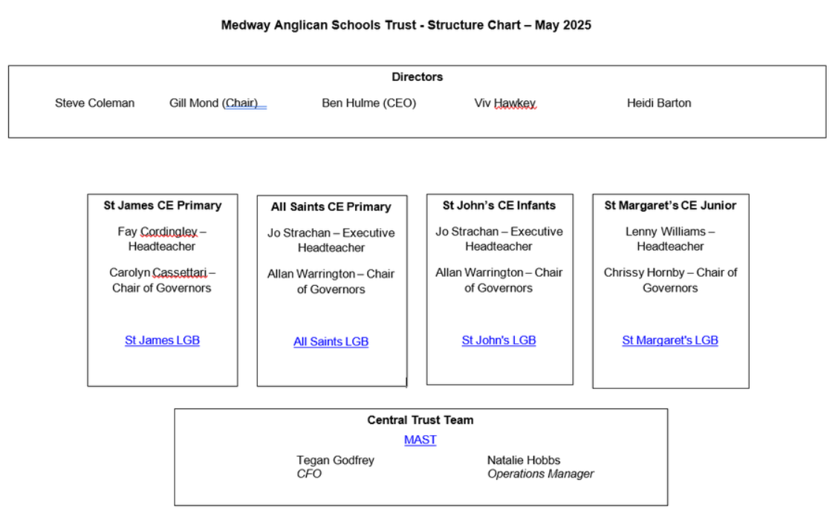

Appendix 2 – External Agencies

His Majesty’s Chief Inspector of Education, Children’s Services and Skills (‘the Chief Inspector’)
Contact them about matters relating to the welfare of children
The Chief Inspector
Ofsted
Piccadilly Gate
Store Street
Manchester
M1 2WD
Tel: 0300 123 3155
Email: whistleblowing@ofsted.gov.uk

Office of Qualifications and Examinations Regulation (Ofqual)
Contact them about matters in relation to which the Office of Qualifications and Examinations Regulation exercise functions under the Apprenticeships, Skills, Children and Learning Act 2009.
Whistleblowing and malpractice
Complaints investigation manager
Ofqual
Earlsdon Park
53-55 Butts Road
Coventry
CV1 3BH
Tel: 0300 303 3344
Email: whistleblowing@ofqual.gov.uk
Online form: complaints.ofqual.gov.uk/new-concern

Secretary of State for Education
Contact them about matters relating to the following educational institutions in England:
- maintained schools
- maintained nursery schools
- independent schools (including academies and free schools)
- non-maintained special schools
- pupil referral units
- alternative provision academies
- 16 to 19 academies (and free schools)
- an institution within the further education sector
- special post-16 institutions
Ministerial and Public Communications Division
Department for Education
Piccadilly Gate
Store Street
Manchester
M1 2WD
Tel: 0370 000 2288
Website: www.gov.uk/contact-dfe

