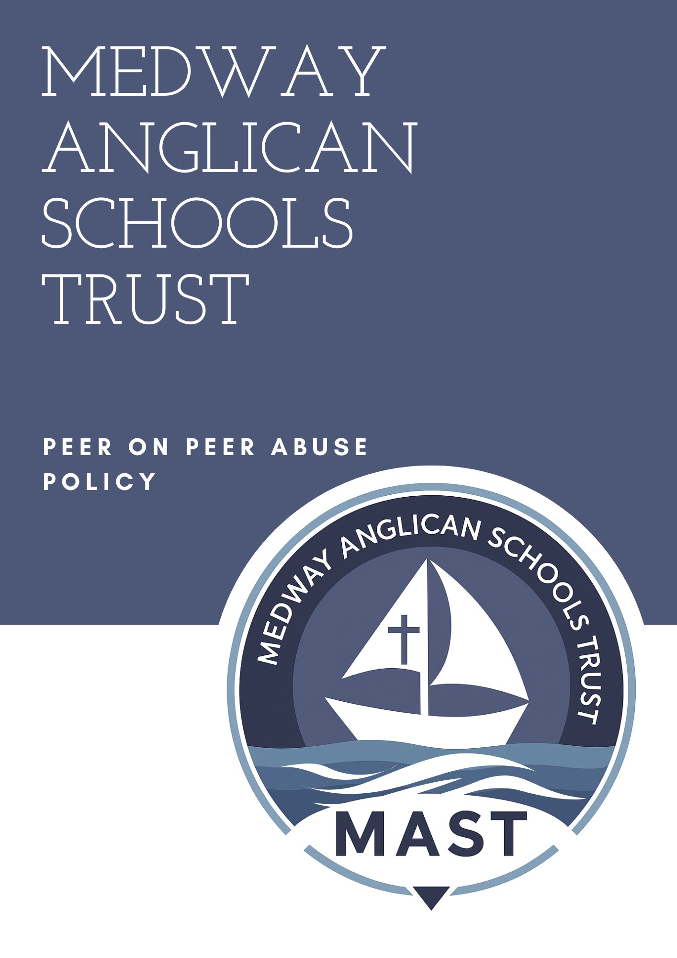
This Peer on Peer Abuse Policy Framework provides a detailed and comprehensive structure that schools in England should use when developing their own policy to prevent, identify, and respond to incidents of abuse between pupils. It aligns with statutory and non-statutory guidance including:
- Keeping Children Safe in Education (KCSIE), 2023
- Working Together to Safeguard Children, 2018 (updated 2023)
- Sexual violence and sexual harassment between children in schools and colleges, 2021 (archived but useful reference)
- Ofsted’s Review of Sexual Abuse in Schools and Colleges, June 2021
- Department for Education (DfE) behaviour and safeguarding guidance

1. Introduction

1.1 Purpose of the Policy
Outline the purpose of the policy and its importance in safeguarding pupils from harm caused by other children.

1.2 Scope of the Policy
Clarify who the policy applies to, including all pupils, staff, and volunteers.

1.3 Legislative and Statutory Guidance
Reference the key pieces of legislation and statutory guidance that underpin the policy, e.g.:
- Children Act 1989 and 2004
- Education Act 2002
- KCSIE 2023
- Human Rights Act 1998
- Equality Act 2010

2. Definition and Types of Peer on Peer Abuse

2.1 What is Peer on Peer Abuse?
Define peer on peer abuse using KCSIE 2023 language — abuse committed by one child against another, which can include both criminal and harmful behaviours.

2.2 Types of Abuse
List and describe the different forms of peer on peer abuse which may include:
- Bullying (including cyberbullying)
- Physical abuse
- Sexual violence (as defined in the Sexual Offences Act 2003)
- Sexual harassment
- Upskirting (a criminal offence)
- Sexting (now referred to as 'sharing of nudes and semi-nudes')
- Initiation/hazing-type violence and rituals
- Relationship abuse
- Exploitation, including county lines and child criminal exploitation (CCE)

3. Aims and Principles

3.1 Aims
- To prevent peer on peer abuse through education and culture
- To respond promptly and appropriately to concerns or disclosures
- To support all pupils who are affected
- To promote a whole-school safeguarding culture

3.2 Principles
- Abuse is abuse, regardless of the age or gender of the perpetrator or victim
- Peer on peer abuse must not be minimised or accepted as “banter” or “just having a laugh”
- Victims will be supported and safeguarded
- Children with SEND, LGBTQ+ pupils, and other vulnerable groups may face increased risk

4. Prevention

4.1 School Ethos and Culture
Describe the school’s commitment to fostering a safe, inclusive, and respectful environment.

4.2 The Curriculum
Explain how the curriculum (especially through PSHE, RSE, and Computing) supports prevention, including:
- Consent
- Online safety
- Healthy relationships
- Respect and boundaries
Ensure alignment with DfE statutory RSE guidance (2019).

4.3 Staff Training
Detail training for all staff to recognise signs of abuse, respond appropriately, and understand relevant safeguarding procedures (see KCSIE 2023 expectations).

5. Procedures for Managing Incidents

5.1 Recognising and Responding to Concerns
Describe procedures staff should follow if they suspect or witness peer on peer abuse, including:
- Reporting to the Designated Safeguarding Lead (DSL)
- Following the school’s safeguarding and child protection policy
- Considering immediate risks to the victim or others

5.2 Recording and Reporting
- Record concerns accurately and promptly
- Use the school’s safeguarding recording system
- Never promise confidentiality to pupils

5.3 Involving Parents and Carers
Outline how and when parents/carers will be informed and involved.

5.4 Risk Assessment and Safeguarding Measures
- Assess the risk to the victim and others
- Consider separation of pupils
- Safeguarding plan and support for all pupils affected
- Liaison with external agencies such as children’s social care, Early Help, and the police

6. Investigation Process

6.1 Role of the DSL
Clarify DSL’s responsibility for leading the safeguarding response and working with external agencies.

6.2 Working with External Agencies
Detail routes for referral and support from:
- Local Authority Children’s Services
- Police (especially where a criminal offence may have occurred)
- CAMHS
- Specialist services (e.g. Barnardo's, NSPCC)

6.3 Confidentiality and Information Sharing
Support safe sharing of information following GDPR and safeguarding protocols (Working Together 2018).

7. Support for Pupils

7.1 Support for Victims
Provide emotional and practical support from pastoral staff or counselling services. This may include:
- Therapeutic support
- Reduced timetable or phased return
- Safe spaces and trusted adults
- Ongoing monitoring

7.2 Support for Alleged Perpetrators
While ensuring accountability and consequences, also offer:
- Behaviour interventions
- Counselling
- Supervision and monitoring
- Education and awareness sessions

7.3 Support for Other Pupils
Recognise the impact on peers and ensure support where appropriate.

8. Managing Sanctions and Discipline

8.1 School Behaviour Policy
Link responses to the school's behaviour and exclusion policies.

8.2 Protective Measures
Discuss appropriate actions including:
- Adjusting timetables
- Moving supervising adults
- Temporary removal from lessons
Balance disciplinary action with support and safeguarding.

9. Monitoring and Review

9.1 Oversight and Accountability
- DSL ensures policy implementation
- SLT and Governors receive regular safeguarding updates
- Safeguarding Governor monitors peer on peer abuse cases

9.2 Evaluating Effectiveness
- Use of incident logs and behaviour records
- Anonymous student surveys
- Feedback from pupils, staff, and parents

9.3 Review Cycle
Review policy annually, or sooner in light of:
- New legislation or DfE guidance
- Ofsted inspection outcomes
- Serious incidents review

10. Linked Policies and Documents
List other relevant policies, including:
- Child Protection and Safeguarding Policy
- Behaviour and Discipline Policy
- Online Safety Policy
- RSE Policy
- Anti-Bullying Policy
- SEND Policy
- Whistleblowing Policy
- Staff Code of Conduct

11. Appendices

Appendix 1 – Key Definitions
Clear definitions of:
- Sexual harassment
- Sexual violence
- Consent
- Grooming
- Exploitation

Appendix 2 – Relevant Legal Frameworks
Brief summaries of relevant laws, including:
- Children Act 1989/2004
- The Sexual Offences Act 2003
- The Equality Act 2010
- The Education Act 2002
Note: This framework should always be tailored to the specific context, age range, and ethos of each individual school. Policies must reflect the school's safeguarding arrangements and be written in accessible language to engage all stakeholders effectively.
For further guidance, refer to your local safeguarding partnership procedures and updates from the Department for Education.

